

Business Requirement document:
Offer Management Project

Table of Contents

1 Document Revisions 3
2 Approvals 3
3 Project Scope 4
3.1 Implementation Approach………………………………………………………………………………..……….4
4 Current State Analysis 4
5 Business Requirements 5
5.1 Functional Requirements 5
5.2 Non-Functional Requirements 7
6 Assumptions 9
7 Appendix 9
7.1 Acronyms 9

Document Revisions

Date | Version Number | Document Changes and details | Edited by
5/10/2024 | 1.9 | Jody reviewed and approved | Dhrithi Dandatikar, Noel Siao, Jody Vaills
05/10/2024 | 1.8 | Internal review | Dhrithi Dandatikar, Noel Siao
05/03/2024 | 1.7 | Review with JODY. Updates to Functional requirements | Dhrithi Dandatikar
04/22/2024 | 1.6 | Updates to Technical requirement/ Scope | Dhrithi Dandatikar
04/10/2024 | 1.5 | Change in Functional Requirements | Dhrithi Dandatikar
02/20/2024 | 1.4 | Project Name change | Dhrithi Dandatikar
02/06/2024 | 1.3 | Updates to the Requirements /Appendix | Dhrithi Dandatikar
01/26/2024 | 1.2 | Updates to the objective/scope | Dhrithi Dandatikar
12/10/2023 | 1.1 | Initial Draft | Dhrithi Dandatikar

Approvals

Doc version | Name of the Approver | Sign-off date
1.9 | Jody Vaills | 5/10/2024

Project Scope
The project aims to create a new Scene+ Offer Management platform that is more efficient, personalized, scalable, robust, and easily configurable and channel centric which is currently not available in Bond Loyalty Engine in its current state​. The platform will help handle more diverse campaigns and offer flows for faster turn-around​.
The new offer management platform will also help implement omni-channel marketing campaigns and deliver real-time, digital offers by connecting the offer platform to the CRM platform​.
3.1 Implementation Approach
- The project will follow a phased approach starting with implementation of Salesforce Loyalty Cloud (MCL), program level offers and any required data integration.
- During this first phase, Bond Loyalty Engine will be used to handle current functionalities such as real-time offers, base offers, BNS offers, and Recipe offers, ensuring uninterrupted service to customers.
- The next phase will be to migrate all the current functionalities in LE to Salesforce.

Current State Analysis
The current state of the BOND Loyalty engine is reflected in the architecture designed below that also showcases the diverse data flows from various partners.
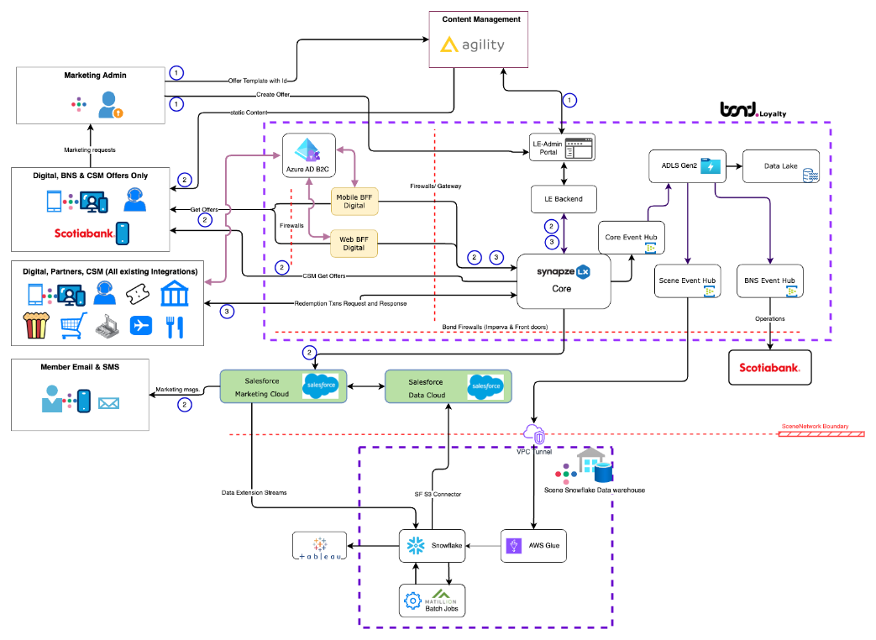
Current state BOND loyalty engine architecture
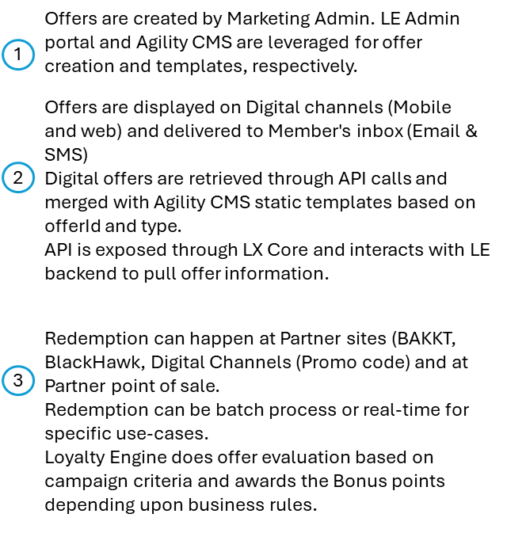

Business Requirements

5.1 Functional Requirements

Req# |  | Requirement | Description | Phase
FR-001 |  | Create and manage new MCL Cross shop offers. | Use your card at a certain location to gain certain points with a min spend required | PHASE 1
FR-002 |  | Create and manage new MCL Redemption offers | Use your card to redeem specific point amount at specific location or any location to earn bonus points | PHASE 1
FR-003 |  | Create and manage new MCL Engagement offers. | Certain digital actions/activities like Survey/Polls rewards, gaming activities e.g. spin ‘n’ win rewards, mobile app engagement rewards e.g. download, and digital Enrolment rewards ​helps you earn certain number of points | PHASE 1
FR-004 |  | Back-end bonus | Automate current manual Back-end bonus (BEB) issuance process | PHASE 1  (BEB is existing)
FR-005 |  | Real time offer evaluation at Point-of-sale | New MCL Offers need to be evaluated in real-time as part of a Point-of-Sale transaction. | Existing for Recipe
FR-006 |  | Ability to load MCL Offers by member | Allow members to activate a MCL Offer in Digital Web or app to redeem it. This will used in the completing evaluation of MCL offers. | New
FR-007 |  | Deliver new offers from Salesforce across CRM channels. | New MCL offers will be pushed to members across CRM channels as per the campaign design (Mobile App, Web, Push notifications, Email, SMS). | PHASE 1  (New)
FR-008 |  | Ability to apply exclusion for items that are not eligible for loyalty currency earn (Pharmacy, alcohol, taxes, tobacco) for existing partners in LE | The system should enable the restriction of creation of offers on certain categories based on user rules that are defined at a Province, Partner Location, User Profile Attributes (e.g.: Liquor Offers at Western Cellers in Alberta) as well as criteria for the % that can be discounted in the value of points vs. the average retail. The restrictions should be defined at the offer level) | Existing for Recipe and Home Hardware Partners only.
FR-009 | PIN Promotions & Promo codes |  | Improve the PIN-based promotions and promo code redemption functionality. | Existing
FR-010 | Point issuance and offer redemption for partners |  | Process points issuance and offer redemption for partners through batch file processing | Existing
FR-011 | Ability to view redemption history for MCL offers |  | Enable CSMs, as well as Digital Web & Mobile platforms, to access member-level issuance and redemption history.  Assumption: will follow current process to view issuance and redemption history in Synapze LX | Existing
FR-012 | CSM access to view MCL Offers |  | Enable CSMs to view offers that are available in Salesforce MCL. | New

FR-013 | Real-time base point issuance and redemption | Ensure real-time point issuance and redemption of base points meeting current Service Level Agreements (SLAs) for Point of Sale (POS) systems.  Assumption: Base points issuance will continue to be managed by Bond through existing processes. | Existing for selected partners in LE
FR-014 | Automate approval process for creation of pre-set offer modules and templates. | Reduce manual processes around signoffs before activation to roll outs campaign more efficiently.  (UAT testing) | New
FR-015 | Display Offers from MCL on digital web | Display MCL offers on the website | PHASE 1
FR-016 | Display offers from MCL on Mobile App | Display MCL offers on mobile applications | PHASE 1
FR-017 | Offer Reporting | Ensure that MCL offer metrics are (allocated, redeemed, points issued) are connected back to reporting systems (tableau, MCI) | PHASE 1

Technical Requirements

Req# | Requirement | Description | Phase
TR-001 | Integration between Marketing Cloud Personalization (MCP) and Digital Web (Agility) | To display the MCL offer on the Sceneplus.ca website | PHASE 1
TR-002 | Integration Between Marketing Cloud Personalization (MCP) and Mobile App (Agility) | To display the MCL offer on the Scene+ Mobile App | PHASE 1
TR-003 | Integration with Scene Snowflake DW | To read and transform Transaction data into MCL Transaction Ledger (Batch). | PHASE 1
TR-004 | Integration between Loyalty Cloud, Data Cloud, Marketing Cloud, and Marketing Cloud Personalization platforms. |  | PHASE 1
TR-005 | Integration between Salesforces MCL and Snowflake ​ | For transaction of Journal data | PHASE 1
TR-006 | API Security | Follow authentication and authorization based on OAuth 2.0 protocols | PHASE 1
TR-007 | API Monitoring | Ability to monitor API execution using logs and dashboards to facilitate troubleshooting in case of failure including specific request/response tracing. | PHASE 1
TR-008 | API key managements | Ensure credentials are stored in a secured vaults and not in configuration files. | PHASE 1

Assumptions and Constraints

Item # | Description
A-01 | All transactions related to offers created and managed in MCL will flow to Synapze LX to snowflake using existing integration. (Point of sale, account related transactions)
A-02 | Currently there is a connection within Salesforce that transfers data to Snowflake
A-03 | There is only one PROD environment for Salesforce and Snowflake. There is non-PROD/UAT environment for Digital Web and Digital Mobile App and Bond Synapze LX eco-system.  End to End (E2E) testing will be challenging and limited.

Appendix

Acronyms

Acronym | Description
API | Application programming interface
BEB | Back-end Bonus
BNS | Bank of Nova Scotia
BRD | Business Requirement Document
CRM | Customer relationship Manager
CSM | Contact Management system (BOND)
LE | Loyalty Engine (BOND)
MCL | Salesforce Marketing Cloud Loyalty
MCP | Salesforce Marketing Cloud Personalization
MCI | Salesforce Marketing Intelligence
OM | Offer Management
POC | Proof of Concept
POS | Point of scale
QA | Quality Assurance
RFP | Request for proposal
RFI | Request for Information
SX | Synapze LX
SFMC | Salesforce Marketing cloud
SFDC | Salesforce Data cloud
SI | System Integration
SOW | Statement of work
SOR | System of record
UAT | User acceptance testing
UI | User Interface
UX | User Experience

